CS&M  Control System & Modeling |  | S.T.I.E  Schneider Toshiba Inverter
Control Strategies for Winder/Unwinder Systems

Key words : | Software Architecture
 | Name |  | Role / Responsibilities |  | Date
Issued by : | Jaouher ROMDHANE |  | R&D Engineer |  | 03/02/2025
Checked by : | Albin INEZA |  | CS&M Engineer |  | 05/02/2025
Approved by :

Change Record
Version | Date | Author | Description
01 | 03/02/2025 | J.ROMDHANE | Initialized document
01 | 05/02/2025 | A.INEZA | Added references sources
01 | 11/02/2025 | J.ROMDHANE | Added SE existing features Vs competitors

Open issues
Info: To mark questions and open issues just format the text with “Open issue”

Info: To mark questions and open issues just format the text with “Open issue” 2

Table of Contents
1. Introduction 4
1.1. Objective of the deliverable 4
1.2. Terminology 4
1.3. References 4
2. Control Strategies for Winder/Unwinder Systems 5
2.1. General Design and structure 5
2.2. Winding technique 5
2.3. Web mechanics 6
2.4. Methods of controlling the tension of web 6
2.4.1. Draw control 6
2.4.2. Open Loop Torque Control 6
2.4.2.1. Open Loop Torque Control (for inline Tensioning) 7
2.4.2.2. Open Loop Torque Control with Speed 7
2.4.2.3. Open Loop Torque Control with Speed and Torque Feed Forward 8
2.4.2.4. Torque Follower Control Modes 8
2.4.3. Closed-loop Tension Control 8
2.4.3.1. Tension feedback with Torque (for inline Tensioning) 9
2.4.3.2. Tension feedback with Speed and Torque Feed Forward 9
2.4.4. Closed-Loop dancer roll control 9
3. SE Winder/Unwinder solution 11
3.1. ATV71 with card option VW3A508 11
3.2. TRACTEL Solution 12
4. Competitors Solutions 14
4.1. ABB 14
4.2. Rockwell automation 15
4.3. Siemens 17
4.4. Lenze 20
5. Conclusion 22
6. Bibliography 23

Introduction

Objective of the deliverable
The goal of this document is to present the current state of art of control strategies for winder/unwinder systems.

Terminology
Acronym | Name | Definition
Web | Web | A web is defined as the material being transported through the machine. It is sometimes referred to as a 'sheet' or 'strip.
Strip | Strip | The strip is defined as the material that is being transported through the machine.
Section | Section | A Web Handling Machine is broken up into sections. A section consists of one or more drives used to propel the material through the line.

References
Template Documents | Reference / Date

Applicable Documents | Reference / Date

Reference Documents | Reference / Date
- SE Internal Solutions
- ABB Solution
- Lenze Solution
- Rockwell automation
- Siemens Solution

Control Strategies for Winder/Unwinder Systems

General Design and structure
A winder solution typically includes a winder drive, a material web, and possibly sensors. Its primary function is to rewind or unwind a material web while maintaining a defined tension, which varies as the diameter changes. The motion control system calculates the actual diameter and adjusts the motor speed to keep tension constant. For enhanced performance and accuracy, sensors such as a dancer roll or load cell may be added.
The dancer roll measures tension by applying adjustable pressure against the material web. When the tension is balanced, the dancer roll remains centered, indicating correct tension. The motion control system keeps the dancer roll centered; any tension changes will shift the roll, triggering adjustments in drive speed.
Additionally, a tension measuring transducer directly monitors system tension and communicates with the motion control system to compensate for any changes by adjusting speed or motor torque.

Winding technique
There are two distinct winding techniques commonly recognized:
- Central Winder: uses a central shaft to drive the roll, with diameter range being crucial for design. Drive speed is inversely proportional to diameter, meaning the minimum diameter sets the maximum speed and maximum diameter determines the required torque. Despite being more complex and harder to control than surface winders, center winders are more widely used [1].

- Surface Winder: the roll is driven through one or more rolls in contact with it, with drive speed and power depending on the roll's diameter. This technique is mechanically more complex than that of a surface winder. The surface winder is used when there are no specific surface quality requirements for the material being wound [1].

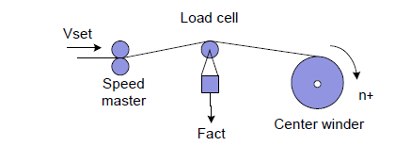
(a)
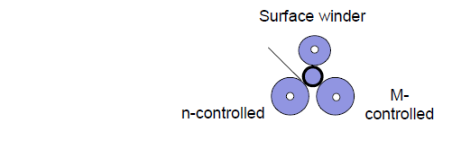
(b)
Figure 1: (a) center winder (b) surface winder

Web mechanics
All materials have a stress-strain relationship. When a material is stretched, it generates force, and the slope of the stress-strain curve is known as Young's Modulus. As strain increases, the material stretches until it eventually breaks. Each type of material has its own Young's Modulus.

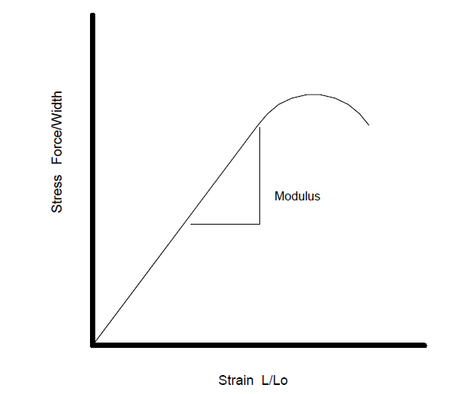
Figure 2: Curve stress-strain.

Methods of controlling the tension of web
The main objective in industrial applications of control Winder/Unwinder is to increase as mush as possible the web transport velocity while controlling the tension of the web. Various control methods are employed in winder/unwinder systems, with the most used techniques in the industry being:
- Draw control
- Closed-loop dancer roll control
- Indirect closed-loop tension control (open-loop torque control)
- Closed-loop tension force control

Draw control
Draw Control refers to control the difference in line speed between two parts of a sections. One roller sets the speed (this is called the master speed), while the speed of the other roller is adjusted to match it. The difference in speed between these two rollers is what we call the "draw."
Tension Control using Draw is a manual operation. The machine operator adjusts the draw setting to keep the web at the right tension.
This control represents the most basic form of tension control. It is usually employed without a tension regulator, but it can also be used for speed offset in machines that stretch the web. However, in applications with variable diameters, relying on draw for tension regulation is insufficient [2].

Open Loop Torque Control
Open loop torque control operates without needing feedback devices for tension or position. Instead, the required torque to adjust the tension between rolls can be calculated.
To determine the needed torque, you add the difference in tension between sections and any losses, then convert that total into a percentage of motor torque.
For Unwind and Rewind operations, the required torque is simply the necessary tension plus any losses, also expressed as a percentage of motor torque [2].
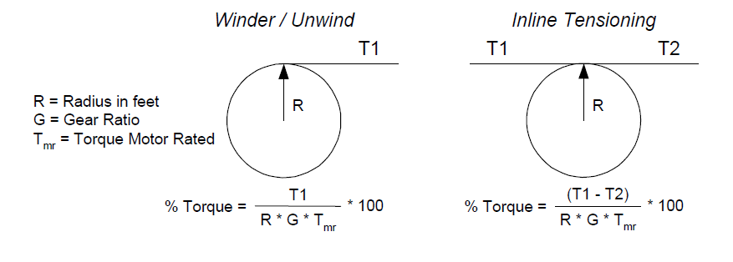
Figure 3: Open loop torque.
Advantages:
- Cost-effective (no need for expensive sensors)
- Simplicity and straightforward implementation
- Suitable for basic applications without complex control needs
Limitations:
- No feedback leads to reduced precision in tension control
- Not suitable for high-performance winding systems

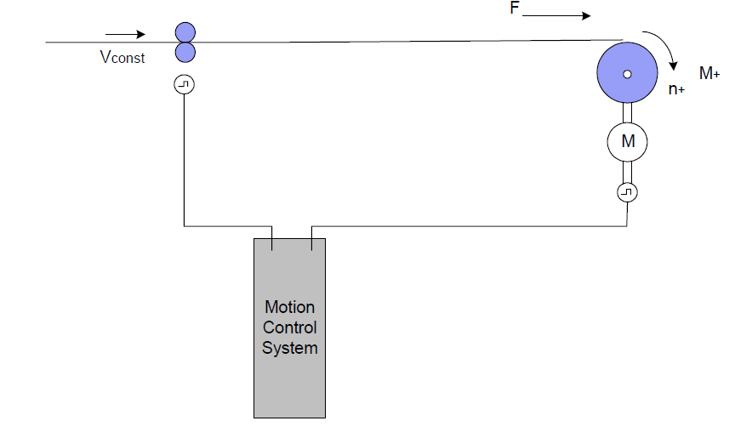
Figure 4: Indirect closed-loop tension control (Open loop torque control)
There are two types of indirect closed-loop tension control (open loop torque control) [1]:
- Open Loop Torque Control (for Inline Tensioning)
- Open Loop Torque Control with Speed
- Open Loop Torque Control with Speed and Torque Feed Froward
- Torque Follower Control Modes

Open Loop Torque Control (for inline Tensioning)
When using this mode of tension regulation in an inline section, you need extra information about the tension in the adjacent section's web. This dynamic information makes the implementation more complex. Therefore, it is not recommended for retrofits or systems with limited engineering resources.

Open Loop Torque Control with Speed
This mode of tension regulation adjusts the speed of the section based on the torque tension set point and actual torque feedback. It is particularly useful for torque applications involving webs with high spring coefficients, like steel.
In this setup, the "master" section (which is speed-regulated) must be synchronized with the torque section using the same speed reference. Tuning this mode can be quite challenging, so it's best handled by experienced engineers. This method is not a typical or conventional form of torque control.

Open Loop Torque Control with Speed and Torque Feed Forward
This tension regulation method adjusts the speed of the section based on the desired torque and the actual torque feedback. Along with adjusting the speed, the torque related to tension is also sent to the drive. This control method is useful for applications involving materials with high spring constants, like steel.
For this setup to work effectively, the 'master' section (which regulates speed) must be synchronized with the torque section using the same speed reference. Tuning this system can be quite challenging and is best left to experienced engineers. This approach is different from typical torque control methods.

Torque Follower Control Modes
The Torque Follower Control Modes operate the same as the Open Loop Torque control modes except the reference input is torque, not tension.

Closed-loop Tension Control
The Tension Control use actual force feedback for precise tension control, known as closed-loop regulation. This method is employed when open-loop torque control lacks the necessary precision, especially in cases of wide torque ranges or when external disturbances affect the system.
A load cell is the device used to measure the actual force applied to the web. Unlike the dancer, the load cell does not exert any force on the web; it simply measures it.
The controlling section is responsible for applying the force to the web by either pulling harder or holding back. The load cell provides the force measurements to this controlling section to help maintain the desired tension.
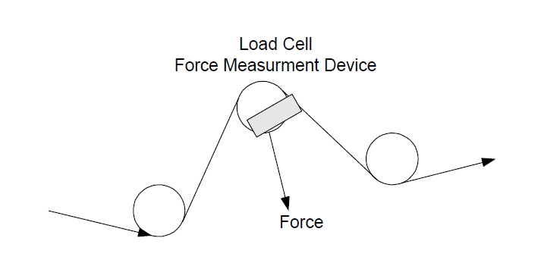
Figure 5 : Load cell
Advantages:
- Improved precision in tension control compared to open-loop control
- Ability to adapt to varying torque settings and disturbances
- Enhanced performance in complex winding applications
Limitations:
- Requires measurement devices, which may increase costs
- More complex to implement than open-loop control

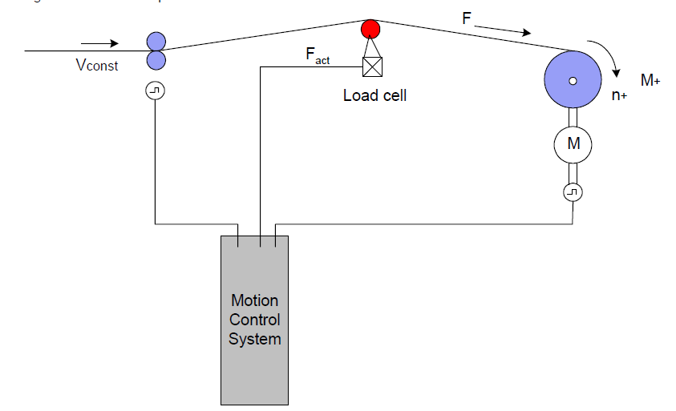
Figure 6: Closed-loop tension control

The are two types of tension feedback control:
- Tension feedback with Torque (for inline Tensioning)
- Tension feedback with Speed and Torque Feed Forward

Tension feedback with Torque (for inline Tensioning)
When using this mode of tension regulation in an inline section, you need extra information about the tension in the adjacent section's web. This dynamic information makes the implementation more complex. Therefore, it is not recommended for retrofits or systems with limited engineering resources.

Tension feedback with Speed and Torque Feed Forward
In this mode of tension regulation, actual web tension is measured using a force measurement device, like a load cell or transducer. The controlling section needs a target tension (set point) and feedback on the actual tension. Based on these inputs, it adjusts its speed to keep the actual tension equal to the set point.
Additionally, the required torque due to tension is sent ahead to the drive. In this setup, the drive’s speed regulator focuses only on maintaining the tension, not on generating the total required torque. As a result, the speed regulator usually operates around zero, regardless of the total torque needed.

Closed-Loop dancer roll control
A dancer is a mechanical device that applies force to the web. This force can come from weights, air pressure, or hydraulic pressure.
When there’s a difference in speed between two sections of the machine, the dancer will move. If the outgoing section moves faster than the incoming section, the dancer moves up, reducing the amount of web stored. Conversely, if the outgoing section moves slower than the incoming section, the dancer moves down, allowing more web to be stored.
The tension applied to the web does not depend on the speed or torque of the regulating section if the mechanical dancer hasn’t reached its minimum or maximum limits. Usually, the controlling section doesn’t know the exact tension needed on the web. Instead, it adjusts its speed to keep the dancer at around 50% of its total travel. The controlling section needs feedback on the dancer's position to do this effectively.

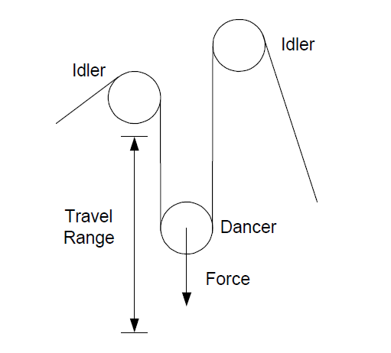
Figure 7: Mechanical dancer.
The closed-loop dancer roll position control system uses a position encoder to determine the dancer roll's position and compare it to a setpoint. Changes in tension affect the dancer roll's position, which is corrected by adjusting the winder speed. This method effectively absorbs brief tension fluctuations, provided the dancer roll does not reach its limits.

Advantages:
- Absorbs brief tension fluctuations due to the dancer roll's material web storage function
- Enhances stability in tension control
- Allows for automatic correction of position offsets through speed adjustments
Limitations:
- Performance is limited by the mechanical design and dynamic characteristics of the dancer roll
- Effectiveness decreases if the dancer roll reaches its operational limits
- Requires mechanical intervention in the material web, potentially complicating the process

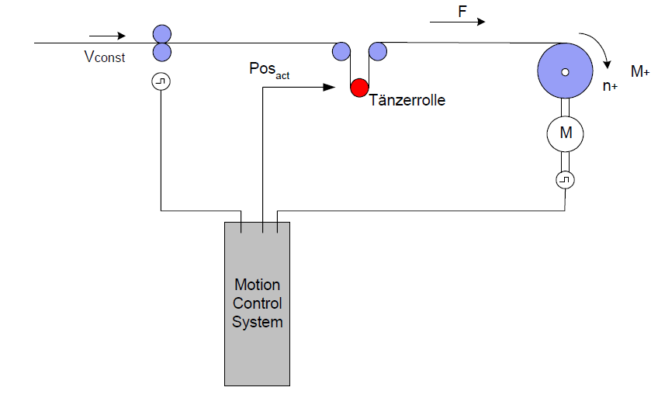
Figure 8: Closed-loop dancer roll position control

SE Winder/Unwinder solution

There are two solutions proposed by STIE for Winder/Unwinder application:
- Winder/Unwinder application control for ATV71 with card option VW3A3508
- TRACTEL Solution

ATV71 with card option VW3A508

We distinguish 4 types of basic functions [3]:
- Feeding or releasing of the film --> line speed regulation.
- Winding --> tension control.
- Unwinding --> speed control or tension control.
- Breakdown or stuck of the machine --> speed control + fast stop.
The main features available are:
- Operation as a winder or unwinder.
- Radius calculation.
- Tension regulation.
- Function tension profile.
- Tension regulation: tension set point.
- Tension regulation: Speed set point.
- Line speed calculation.
- Compensation for inertia.
- Compensation for frictions.

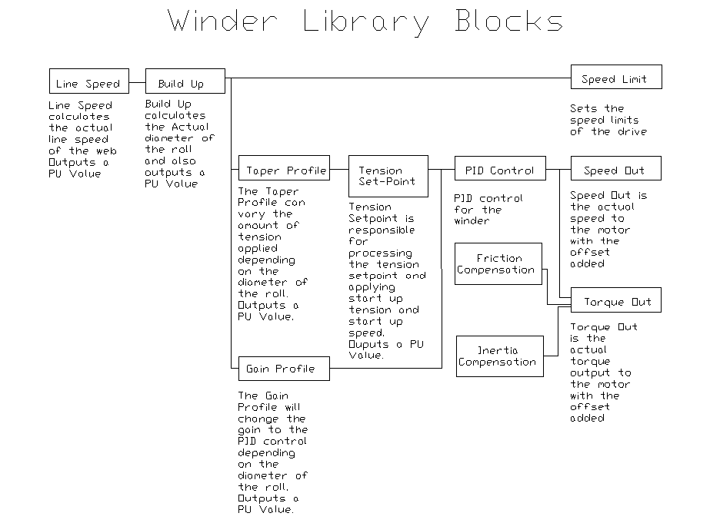
Figure 9: Library Blocks

Figure 10 : Principal Diagram System

TRACTEL Solution

- Automate TSX PREMIUM Unity.
- DCVN or ALTIVAR CVF Variable Speed Drives.
- Understanding of Mechanics and Pilot Section.

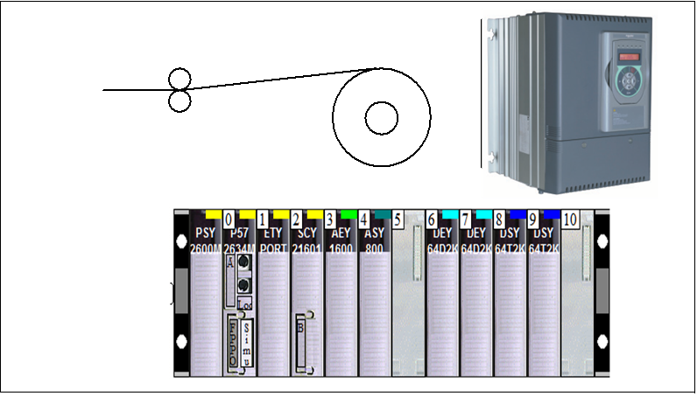
Figure 11: Tractel solution
The main features available are [4]:
- Operation as a winder or unwinder.
- Winding or unwinding from the top or bottom.
- Real-time radius calculation.
- Decreasing tension slope based on radius.
- Calculation of spool inertia.
- Calculation of motor and spool acceleration torques.
- Compensation for static and viscous friction
- Tension correction using gauges.
- During the auto-tuning phase, calculation of static and viscous friction, as well as motor and gearbox inertia

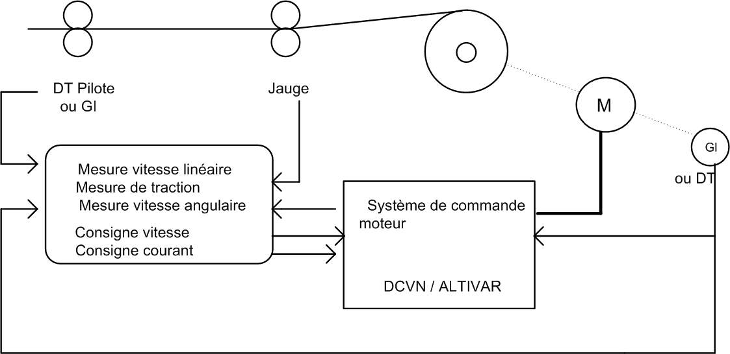
Figure 12: Principal Diagram of System

Competitors Solutions

ABB
ABB proposed a winder/unwinder control. The solution is proposed in ACS880 winder control program (option +N5000) [5].

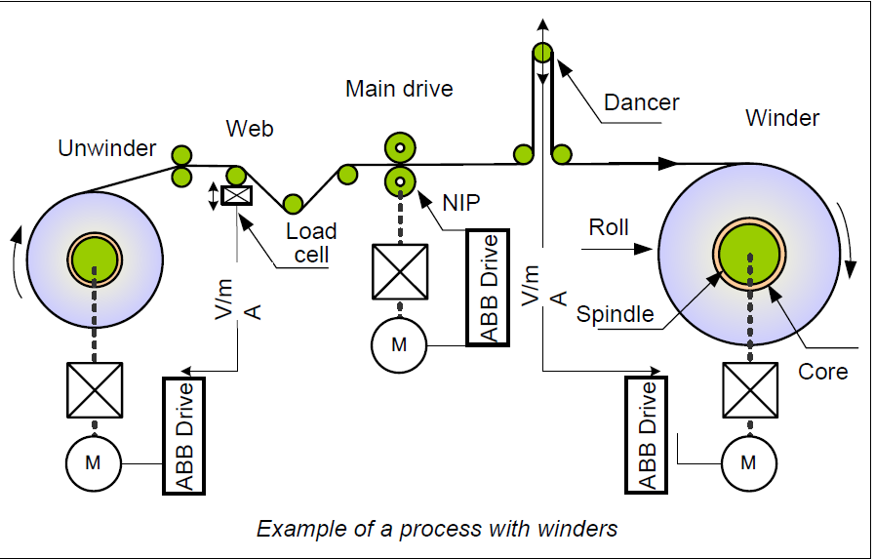
Figure 13: Process with winders.
The main features available are:
- Diameter calculation.
- Tension/Dancer Control.
- Open Loop Tension Control
- Tension Torque trim Control.
- Tension Speed trim Control.
- Dancer Speed trim Control
- Taper Function
- Friction Compensation
- Inertia Compensation
- Winder stall function
- Torque memory.
- Automatic Roll change
- Web loss
- Virtual roll Control
- Speed control torque limitation
- Tension to torque conversion
- Winder control word logic

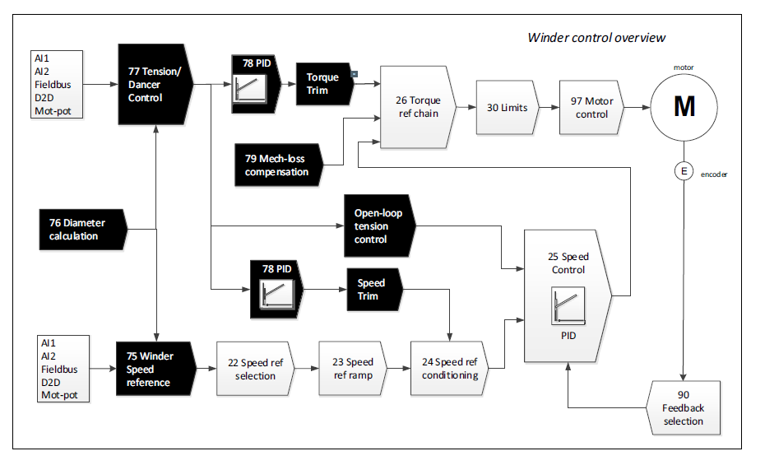
Figure 14: ABB Winder control overview.

Rockwell automation

Rockwell automation propose a product that can be used in applications with variable diameter spindle based on tension feedback from a load cell, uses Torque Regulator to control web tension of material in center driven [2].
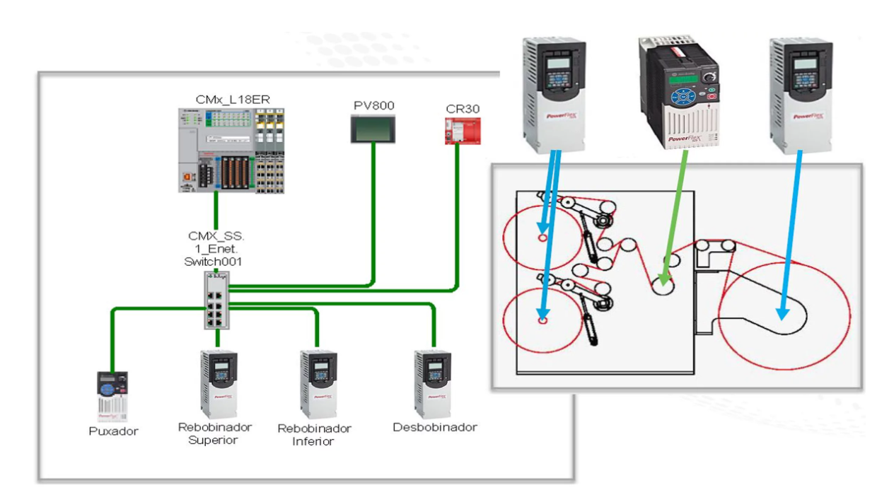
Figure 15 : Rockwell automation control overview.
The main features are:
- Center Driven application.
- Torque control for Winder, Unwinder drives.
- Speed Limited Adjustable Torque
- Speed control for the puller drive.
- Speed follows a virtual axis.
- Tension control at line speed.
- Full tension control when accelerate and decelerate.
- Flexible parameters
  - Reference speed of machine.
  - Acceleration time.
  - Deceleration time.
  - Roll Unwind tension control.
  - Roll Wind tension control.
  - Roll length control.
  - Roll diameter control.
- Drive status, Alarms and Faults.
Advantages:
The Winders controlling web tension in a center driven has excellent accuracy of torque control for web material.
- Flexible, Predictive Diagnostics, Integrated Safety. • Automatic Device Configuration.
- Integrated Architecture.
- Speed Limited Adjustable Torque.

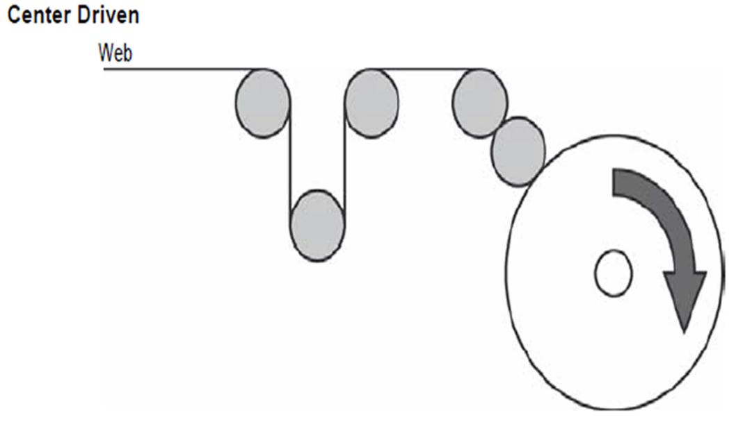
Figure 16: center driven.
Limitations / Disadvantages
- Drive for Unwinder and Winder must have torque control.
- Must adapt the application if use Surface Driven.

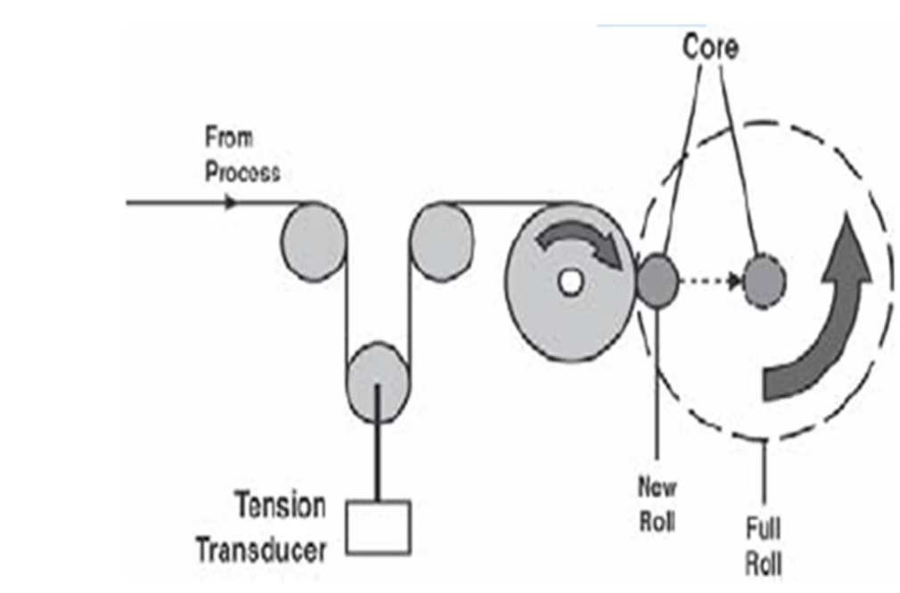
Figure 17: Surface Driven
Use when:
- Controlling web tension in a center driven (un)winder.
- Torque Control to control web tension.
- Tension feedback device is a load cell or a dancer.
Do NOT use when:
- Speed Trim Regulator to control web tension is preferable is over Torque control.
- Drive has no torque control feature.
- Surface driven for Winder or Unwinder. Must adapt the application to calculate it.

Application areas
- Web Material, CPW, Converter, Printer, Metals, Plastics

Siemens

Siemens propose a winder application intended for users that want to implement a winder function using easily and quickly SIMOTION [1].

The main features:
- Diameter calculator
- Tension Taper characteristic.
- Controller adaptation
- Inertia compensation

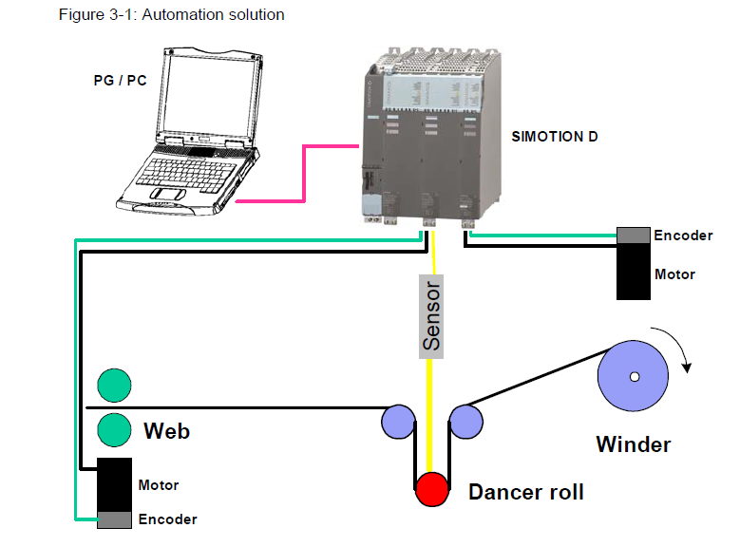
Figure 18: Automation solution.

They proposed four control strategies:
- Direct closed-loop tension control with dancer roll using speed correction.
- Direct closed-loop tension control using speed correction and a tension measuring transducer.
- Direct closed-loop tension control using torque limiting and load cell.
- Indirect closed-loop tension control.

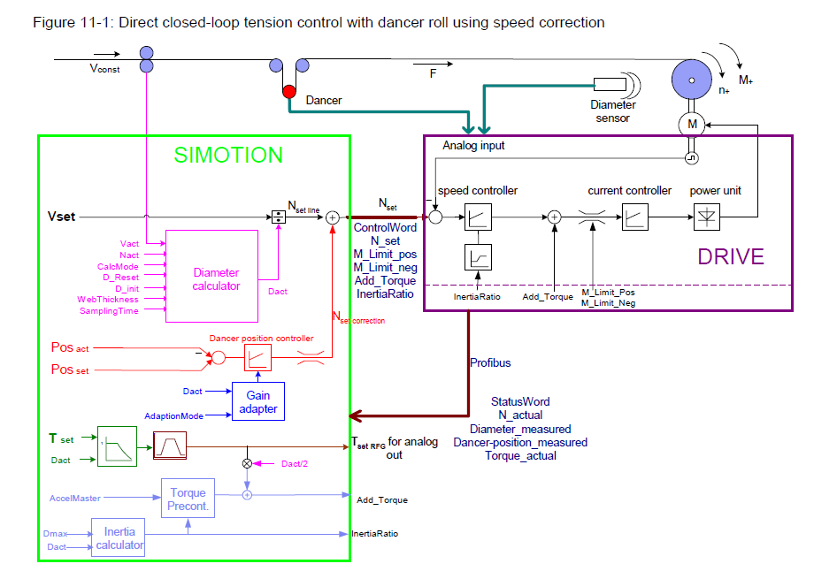
Figure 19: Direct closed-loop control with dancer roll using speed correction.

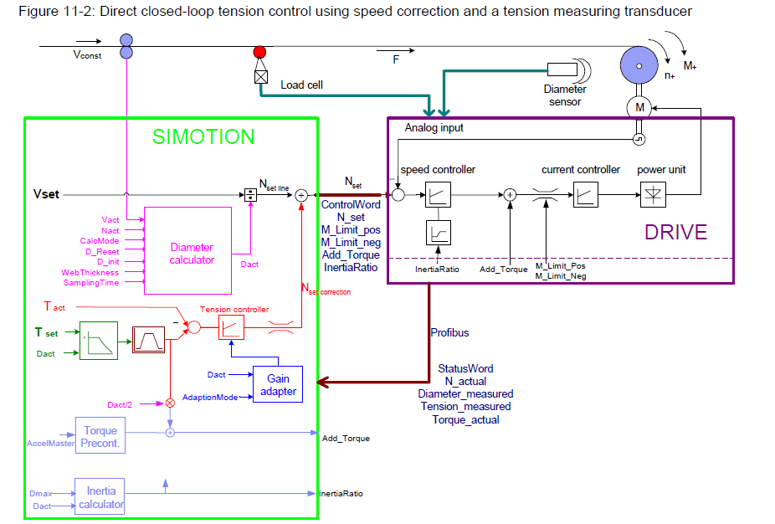
Figure 20:Direct closed-loop tension control using speed correction and a tension measuring transducer.

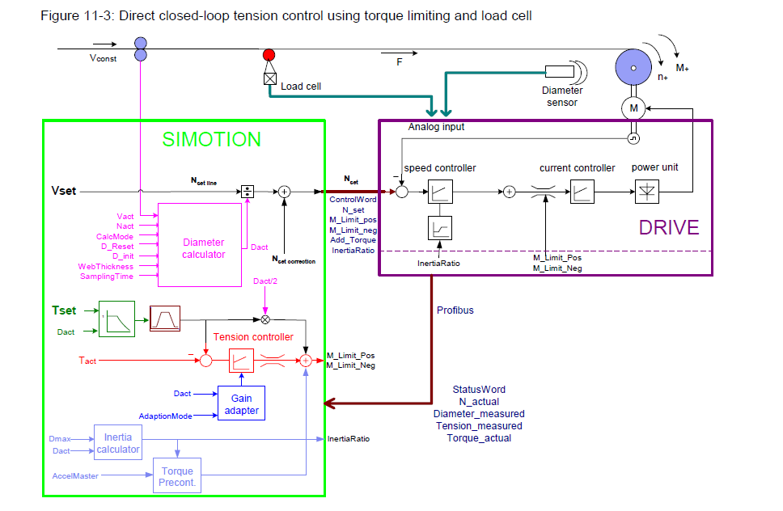
Figure 21: Direct closed-loop tension control using torque limiting and load cell.

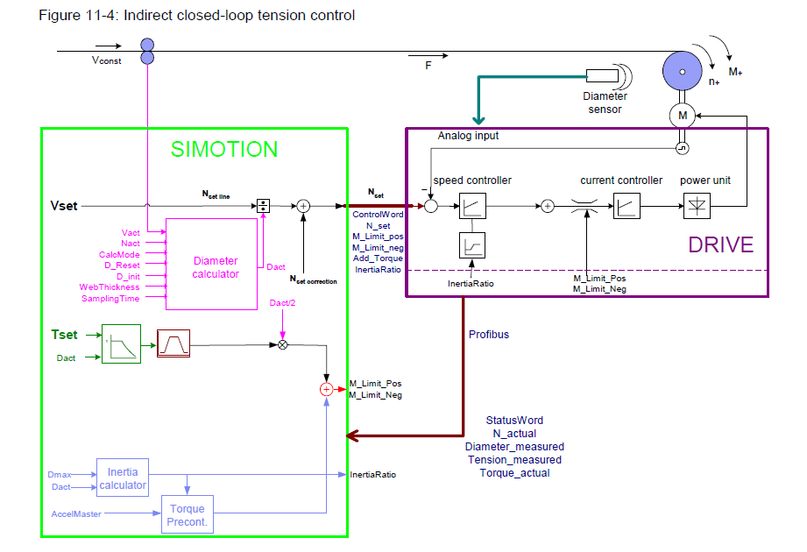
Figure 22: Indirect closed-loop tension control.
They proposed also various technique to determine the roll diameter:
Diameter calculation:
- From sensor
- From the relationship between the actual speed and the circumferential velocity.
- By incrementally adding the material thickness at the specified speed
- By the ratio between the web length for one or several revolutions of the winder.

Lenze
Lenze propose a "Winder" software package provides solutions for centre winding machines with dancer control or tensile control (open-loop or closed-loop) [6].

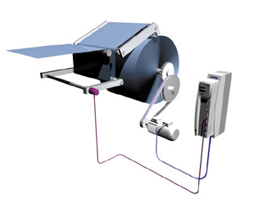
Figure 23: Software Package- Winder

The "Winder" software package provides solutions for centre winding machines with dancer control or tensile control (open-loop or closed-loop).

The Features - Open-loop/closed-loop tension control:
- Internal diameter calculation
- Traction configured via ramp generator
- Open-loop tension control via characteristic curve function
- Automatic identification of the current mass moment of inertia and friction
- Acceleration torque and friction compensation
- Calculation of material density with landing computer
The Features - Dancer position control
- Diameter calculated internally with dancing roller motion compensation
- Teaching of dancing roller end positions
- Tensile force controlled via characteristic curve function using dancing roller
- Automatic identification of the current mass moment of inertia
- Acceleration torque compensation
- Calculation of material density with landing computer

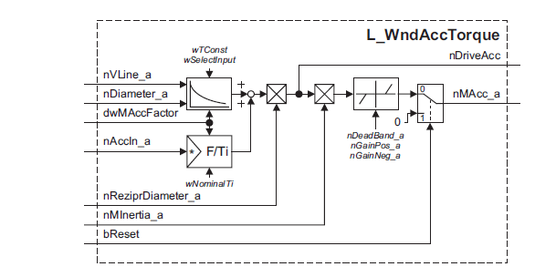
Figure 24: Acceleration Compensation

The area of application is:
- Cables, wires, textiles, paper, sheet steel, metal strip, thin metal foil.

Conclusion

The table below provides a comprehensive comparison between Schneider Electric's winder/unwinder solutions and those proposed by competitor:

Feature | SE ATV71 | SE Tractel | ABB | Rockwell | Siemens | Lenze
Open-Loop Torque Control
Open Loop Torque |  |  | x | x | x | x
With Speed Trim |  |  | x | x | x | x
With Speed Trim and Torque FF |  |  |  | x
Torque Follower |  |  |  | x
Closed-Loop Tension Control
With Speed Trim | x | x | x | x | x | x
With Torque Trim | x |  | x | x | x | x
With Speed Trim and Torque FF |  |  |  | x
Closed-Loop dancer roll Control
With Speed Trim |  |  | x | x | x | x
With Torque Trim |  |  |  | x | x | x
With Speed Trim and Torque FF |  |  |  | x
Diameter Calculation
From sensor | x |  | x | x | x | x
From actual speed and circumferential velocity | x | x | x | x | x | x
From the material thickness and the specified speed |  |  | x | x | x
From the web length and winder revolutions |  |  |  |  | x
Flexible parameters
Reference speed of machine |  |  |  | x | x | x
Acceleration time |  |  |  | x
Deceleration time |  |  |  | x
Roll Unwinding tension control |  |  |  | x
Roll Winding tension control | x | x |  | x
Roll length control |  |  |  | x
Roll diameter control |  |  |  | x | x
Taper function | x |  | x | x | x | x
Inertia Compensation | x | x | x | x | x | x
Friction Compensation | x | x | x | x | x | x
Acceleration torque compensation | x | x | x | x |  | x
Density material Calculation |  |  |  |  |  | x
Torque memory |  |  | x
Web loss |  |  | x |  |  | x
Virtual roll control |  |  | x
Tension correction using gauges |  | x
Tension control at line speed | x |  | x | x | x | x

Bibliography

[1] « Standard Application Winder with SIMOTION V1.1 ».
[2] « Rockwell Automation Tension control_9329-RM002B-EN-E ».
[3] « Maquette_Guide Eploitation Enrouleur_Derouleur ».
[4] « Présentation TRACTEL ».
[5] « ABB ACS880 winder control program ».
[6] Lenze, « Lenze Software Package Winder Tension Control ».

